**S. Y. B. Tech (EE)**

**Trimester: V Subject:** Analog and Digital Integrated Circuits

**Name: Class:**

**Roll No: Batch:**

**Experiment No:**

**Name of the Experiment:** Design and implement 2 bit R-2R Ladder DAC.

**Marks**

**Teacher’s Signature with date**

**Performed on:**

**Submitted on:**

**Aim**: Design and implement 2 bit R-2R Ladder DAC **Pre-requisite:** Op-Amp in Inverting Mode

**Objectives:**

* Measure and Verify output voltage practically and theoretically.
* Calculate resolution, step size and few more specifications.

**Components and equipment required:**

Bread Board, Op-Amp-OP-07C, Resistors, Dual Power Supply and, DMM

**Theory:**

**Digital-to-Analog Converter (DAC)**

A digital-to-analog converter, or simply DAC as shown in Figure 8.1, is a semiconductor device that is used to convert a digital code into an analog signal.  Digital-to-analog conversion is the primary means by which digital equipment such as computer-based systems are able to translate digital data into real-world signals that are more understandable to or useable by humans, such as music, speech, pictures, video.

DACs are commonly used in [music players](https://en.wikipedia.org/wiki/Digital_audio_player) to convert digital data streams into analog audio signals. They are also used in [televisions](https://en.wikipedia.org/wiki/Television) and [mobile phones](https://en.wikipedia.org/wiki/Mobile_phone) to convert digital video data into analog video signals which connect to the screen drivers to display monochrome or color images. It also allows digital control of machines, equipment, household appliances

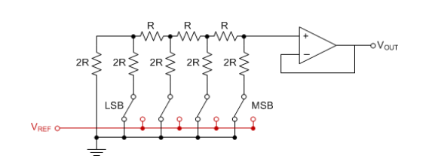

**Figure 8.1: R-2R Ladder**

Linearity(Ideal Case)

Digital Input

**Perfect Agreement**

Desired/Approximate Output

NON-Linearity(Real World)

Digital Input

Desired Output

**Miss-alignment**

Approximate output

**Figure 8.2 : Linearity graphs**

**Performance Specifications of DAC:**

**• *Resolution***

The resolution of a converter is the smallest change in voltage which may be produced at the output (or input) of the converter. For example, an 8-bit D/A converter has 2^8-1=255 equal intervals. Hence the smallest change in output voltage is (1/255) of the full scale output range.

* Resolution should be high as possible. It depends on the number of bits in the digital input applied to DAC.
* Higher the number of bits, higher is the resolution.

It can also be defined as the ratio of change in analog output voltage resulting from a change of 1 LSB at the digital input. For n-bit DAC

Resolution= $\frac{V_{fs}}{\left(2^{n}-1\right)}$………. (8.1)

Where Vfs=full scale voltage

• ***Accuracy***

Absolute accuracy is the maximum deviation between the actual converter output and the ideal converter output. Accuracy is a comparison of the actual output of a DAC with the expected output.

• ***Linearity***

A linear error is a deviation from the ideal straight-line output of a DAC. A special case is an offset error, which is the amount of output voltage when the input bits are all zeros. The relation between the digital input and analog output should be linear as shown in Figure 8.2.

• ***Monotonicity***

A monotonic DAC is the one whose analog output increases for an increase in digital input. A monotonic characteristic is essential in control applications, otherwise oscillations can result. If a DAC has to be monotonic, the error should be less than ±(1/2) LSB at each output level.

• ***Settling******time***

Settling time represents the time it takes for the output to settle within a specified band ±(1/2) LSB of its final value, after the change in digital input. It should be as small as possible.

### Procedure:

i) Do the connections as shown in Figure 8.3.

ii) Calculate the output voltage theoretically.

iii) Apply different combinations of b1 and b0 refer observation table.

iv) Observe the output voltage and compare with theoretical voltage.

v) Measure resolution, offset error.

### Circuit Diagram:

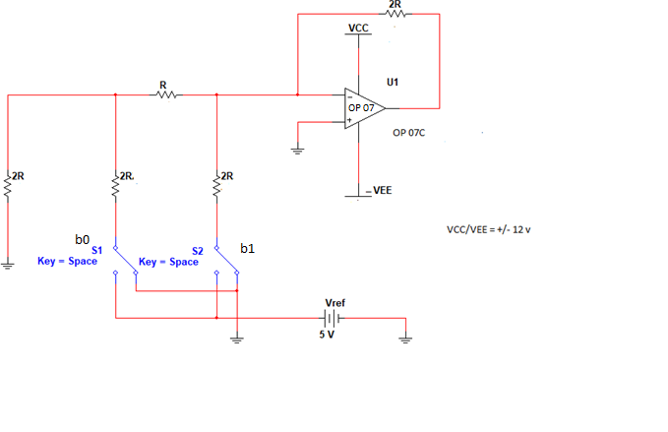

**Figure 8.3: 2 bit R-2R DAC**

**Vref/255=**



**Figure 8.4: 8 bit DAC-Multisim Implementation**



**Figure 8.5: 8-bit ADC- Multisim Implementation**

**0,1,2……9,A,B…..F**

**5V- 1111 1111-FF**

**2.5 – 1000 0000- 80**

### Design Steps:

Select two resistors of type R and 2R for DAC

Let’s assume R =7.5K so then 2R =15K (by design).

Calculate Output Voltage by the given formula in equation 8.2.

**Calculations: Calculate output voltage for different combinations of b1 and b0**

Vo = ……….(8.2)

Vref = 5V, gain = 2

Attach separate sheet

**Observation Table: 2-bit Op-Amp based circuit**

|  |  |  |  |
| --- | --- | --- | --- |
| **b1(MSB)** | **b0(LSB)** | **Vtheorotical** | **Vpractical** |
| 0 | 0 | 0 | 0 |
| 0 | 1 | -2.5 |  |
| 1 | 0 | -5.0 |  |
| 1 | 1 | -7.5V |  |

8-Bit DAC

|  |  |  |
| --- | --- | --- |
| b7b6…….b0 | **Vtheorotical** | **Vpractical** |
| 00000000 |  |  |
|  |  |  |
|  |  |  |
|  |  |  |
|  |  |  |
|  |  |  |
| 11111111 |  |  |

8-bit ADC

|  |  |  |
| --- | --- | --- |
| Vin (volts) | Theoretical Output | Hexadecimal output |
|  |  |  |
|  |  |  |
|  |  |  |
|  |  |  |
|  |  |  |
|  |  |  |
|  |  |  |

**Conclusion:**

**Post Lab Questions:**

1. Why Precision Op-amp is used to perform this practical?

2. What would be the change in resolution formula if we increase the number of bits?

3. If we need to make the resolution better what changes should be made in circuit?

**Additional links for more information:**

<https://www.elprocus.com/digital-to-analog-converter-dac-applications>

http://ume.gatech.edu/mechatronics_course/DAC_S06.ppt